Chapter 19, Problem 74.

Determine the ABCD parameters of the circuit in Fig.19.120 functions of s. Hint: Partition the circuit into subcircuits and cascade them using the results of Prob. 19.35.)

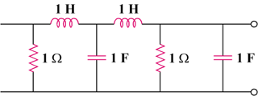

Figure 19.120
For Prob. 19.74.

